PROJECT REPORT
METRO TICKET GENERATING SYSTEM IN SERVICENOW
Digital Metro Ticketing with Automated Fare Calculation and QR Codes
Date: 8 October 2026
Student Name: Oviyashree

Project Documentation

Technology: ServiceNow
Features: Service Catalog, Flow Designer, Notifications
Project: Metro Ticket Generating System in ServiceNow

TABLE OF CONTENTS
1. INTRODUCTION
2. IDEATION PHASE
3. REQUIREMENT ANALYSIS
4. PROJECT DESIGN
5. PROJECT PLANNING & SCHEDULING
6. FUNCTIONAL AND PERFORMANCE TESTING
7. RESULTS
8. ADVANTAGES & DISADVANTAGES
9. CONCLUSION
10. FUTURE SCOPE
11. APPENDIX

1. INTRODUCTION
1.1 Project Overview
Digitize metro ticket booking using ServiceNow to enable fast, accessible, and automated ticket generation through QR codes. The system allows users to book tickets by selecting stations and travel details, automatically calculates fares, and generates digital tickets instantly. It streamlines metro operations using Service Catalog, Flow Designer, and Notifications for a seamless and efficient travel experience.
The system replaces manual counter-based ticketing with a guided, automated process, reducing queues and errors while creating a foundation for digital payments and data-driven planning.
1.2 Purpose
- Enhance Commuter Convenience: Implement user-friendly digital ticketing options such as mobile apps, QR codes, and WhatsApp-based bookings to reduce wait times and streamline the ticketing process.
- Increase Operational Efficiency: Adopt Automated Fare Collection (AFC) systems to minimize manual interventions, reduce errors, and lower operational costs.
- Promote Digital Payment Adoption: Encourage the use of digital payment methods like UPI, credit/debit cards, and mobile wallets to facilitate cashless transactions and improve revenue collection.
- Facilitate Data-Driven Decision Making: Utilize data analytics from digital transactions to gain insights into passenger behavior, peak usage times, and route optimization opportunities.
- Support Environmental Sustainability: Reduce paper usage by transitioning to digital tickets, contributing to eco-friendly practices and aligning with sustainability goals.
Users: Passengers (end users), Station Managers, Metro Operations Team and IT Admins.
2. IDEATION PHASE
2.1 Problem Statement
Metro passengers face long queues, manual fare errors and paper tickets. Without automation, station and operations teams also lack accurate, digital records. The project solves this with a guided ServiceNow ticket booking process that calculates fares and issues QR code tickets instantly.
2.2 Empathy Map Canvas
Perspective | Project Interpretation
Says | I need a fast way to book a metro ticket.
Thinks | I want the fare to be correct and the QR ticket to scan.
Does | Selects stations, enters travel details and submits.
Feels | Wants a quick and reliable travel experience.
Pain Points | Queues, fare errors, paper tickets.
Needs | Automated fare, instant QR ticket, simple booking.
2.3 Brainstorming
- Create a Service Catalog item for ticket booking with Source, Destination, Passenger Type and Number of Tickets.
- Automate fare calculation with a fare logic script.
- Generate QR code digital tickets.
- Map station details to bookings.
- Use Flow Designer and Notifications for confirmations.
- Build user-facing UI pages.
3. REQUIREMENT ANALYSIS
3.1 Customer Journey Map
Stage | Passenger Action | System Response | Expected Outcome
Access | Open booking page | Loads catalog form | Passenger can start booking
Select | Choose source, destination, passenger type, quantity | Applies defaults and validation | Valid data captured
Fare | Review fare | Fare Logic Script calculates fare | Correct fare shown
Submit | Submit booking | Ticket record and QR code created | Digital ticket issued
Notify | Receive confirmation | Notification sent | Passenger has ticket
Travel | Show QR at gate | Ticket validated | Passenger travels
3.2 Solution Requirements
Functional Requirements
FR No. | Functional Requirement | Sub-Requirement / Expected Behavior
FR-1 | Ticket Booking Catalog Item | Service Catalog item with variables Source, Destination, Passenger Type and Number of Tickets.
FR-2 | Field Validation | Non-empty source/destination, fare match and approved travel date.
FR-3 | Mandatory Fields | Enforced on client and server side to prevent incomplete submissions.
FR-4 | Auto-Populate Logic | Default values (e.g., single or return journey) using catalog client scripts and UI policies.
FR-5 | Fare Calculation | Fare is calculated automatically from stations, passenger type and number of tickets.
FR-6 | QR Code Generation | A digital ticket with a QR code is generated instantly after booking.
FR-7 | Station Details Mapping | Station details are mapped to the booking for fare and validation.
FR-8 | Field Mapping | Process Automation Engine auto-maps and populates values entered by the user.
FR-9 | Notifications | Booking confirmation sent through Flow Designer and Notifications.
FR-10 | UI Pages & Testing | User-facing UI pages, followed by UAT and deployment.
Non-Functional Requirements
NFR No. | Requirement | Description
NFR-1 | Usability | Simple and fast booking experience.
NFR-2 | Data Consistency | Validation and mapped fields reduce wrong entries.
NFR-3 | Reliability | Booking consistently creates the intended ticket and QR code.
NFR-4 | Maintainability | Catalog, scripts, flows and pages are configured separately.
NFR-5 | Security | ServiceNow role-based access controls.
NFR-6 | Performance | Responsive booking and ticket generation.
3.3 Data Flow Diagram
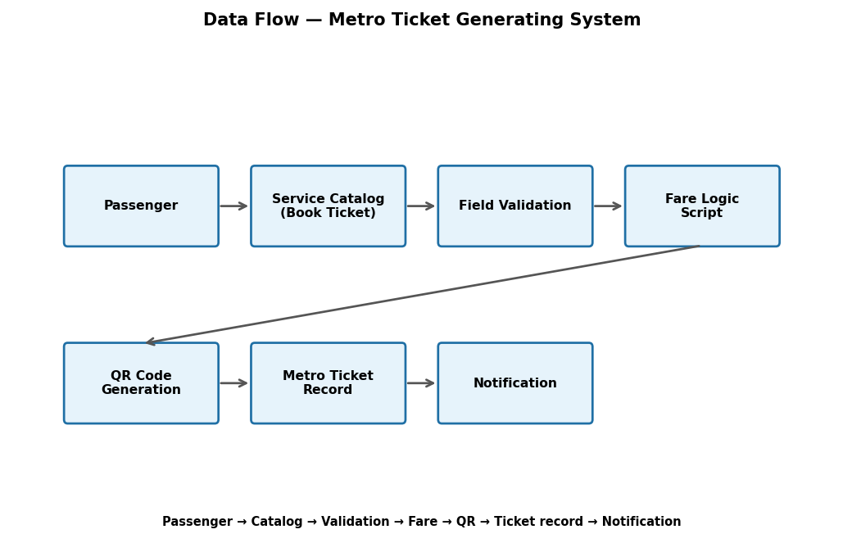
Figure 1: High-level flow from passenger booking to the digital QR ticket.
3.4 Technology Stack
Component | Technology / Configuration | Purpose
Platform | ServiceNow | Application platform.
Catalog | Service Catalog item | Guided ticket booking.
Automation | Flow Designer, Process Automation Engine | Workflow and field mapping.
Scripts | Catalog Client Scripts, Fare Logic Script | Validation, defaults and fare calculation.
Notifications | ServiceNow Notifications | Booking confirmation.
QR Code | QR Code Integration | Digital ticket generation.
Interface | UI Pages | Passenger-facing pages.
Data | Ticket and Station tables | Store bookings and station details.
4. PROJECT DESIGN
4.1 Problem-Solution Fit
Parameter | Project Fit
Problem | Manual ticketing causes queues, errors and paper use.
Solution | Automated ServiceNow ticketing with fare calculation and QR codes.
Customer Benefit | Fast, accessible booking.
Operational Benefit | Fewer manual steps and errors.
Scalability | Payments, analytics and WhatsApp booking can be added.
4.2 Proposed Solution
A Service Catalog item collects booking details; validation, auto-populate and mapping rules keep data consistent; a fare logic script and QR code integration produce the digital ticket; Flow Designer and Notifications inform the passenger.
4.3 Solution Architecture
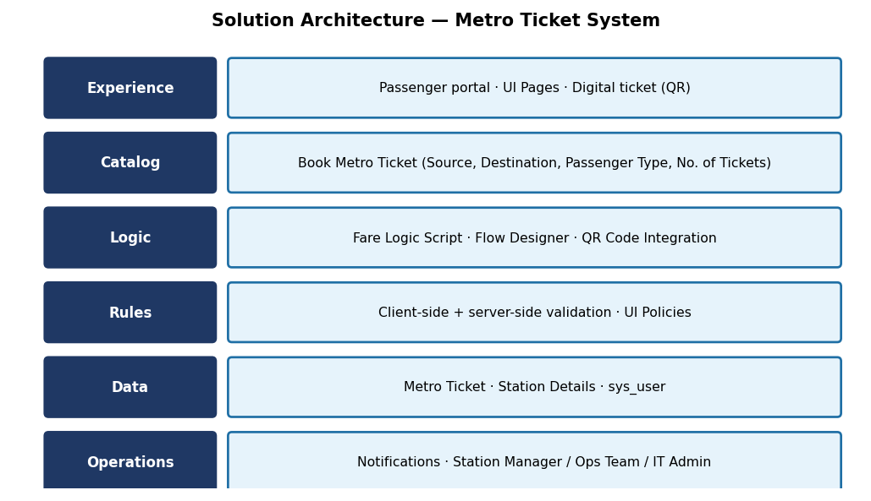
Figure 2: Metro Ticket solution architecture.
Data Architecture
Data architecture is the blueprint for how data is collected, stored, managed, integrated, and used across an organization. It defines the policies, standards, models, and rules that govern how data flows and supports business objectives.
Validation & Data Handling
Item | Description
Field validations | Non-empty source/destination, fare match, approved travel date.
Mandatory fields | Enforced on client and server side to prevent incomplete submissions.
Auto-populate logic | Default values (e.g., single, return journey) using catalog client scripts and UI policies.
Fields mapping | Process Automation Engine auto-maps fields and populates values given by the user/clients.
5. PROJECT PLANNING & SCHEDULING
5.1 Project Planning
Execution roadmap milestones: Catalog Form Setup → Fare Logic Script → QR Code Integration → Station Details Mapping → UI Pages → UAT & Deployment.
Phase / Sprint | Major Tasks | Deliverable
Sprint 1 – Catalog Form Setup | Create catalog item and variables. | Booking form.
Sprint 2 – Fare Logic Script | Fare calculation and validations. | Automatic fare.
Sprint 3 – QR Code Integration | Generate QR code for tickets. | Digital ticket.
Sprint 4 – Station Details Mapping | Map stations and auto-populate. | Mapped station data.
Sprint 5 – UI Pages | Build UI pages, flows and notifications. | Passenger interface.
Sprint 6 – UAT & Deployment | Test and deploy. | Validated solution.
6. FUNCTIONAL AND PERFORMANCE TESTING
6.1 Performance Testing
Testing focused on functional correctness and user interaction rather than load benchmarking.
Test ID | Test Scenario | Expected Result | Status
TC-01 | Open booking form | Catalog item loads | Pass
TC-02 | Select source and destination | Stations selectable | Pass
TC-03 | Empty source/destination | Validation error shown | Pass
TC-04 | Default journey type | Single/return default populated | Pass
TC-05 | Fare calculation | Fare matches selection | Pass
TC-06 | Invalid travel date | Unapproved date rejected | Pass
TC-07 | Mandatory fields | Incomplete form blocked | Pass
TC-08 | QR code generation | QR code generated on ticket | Pass
TC-09 | Notification | Confirmation sent | Pass
TC-10 | End-to-end | Complete booking flow works | Pass
Performance note: formal concurrent-user/load testing was not part of the supplied implementation evidence.
7. RESULTS
7.1 Output Screenshots
Screenshots are reserved for the final submission. Insert the following:
Figure | Recommended Screenshot
Figure 3 | Ticket booking catalog form.
Figure 4 | Source, destination and passenger type selection.
Figure 5 | Validation messages for missing fields.
Figure 6 | Automatically calculated fare.
Figure 7 | Generated digital ticket with QR code.
Figure 8 | Booking confirmation notification.
Figure 9 | Metro ticket record in ServiceNow.
8. ADVANTAGES & DISADVANTAGES
Advantages
- Fast and accessible ticket booking.
- Automated fare calculation reduces errors.
- QR code digital tickets reduce paper use.
- Supports digital payments and data-driven decisions.
Disadvantages
- Depends on ServiceNow instance availability and internet access.
- Payment gateway and WhatsApp booking are not yet implemented.
- No formal load testing performed.
9. CONCLUSION
The Metro Ticket Generating System in ServiceNow digitizes ticket booking end to end, from a validated catalog form to automatic fare calculation and an instant QR code ticket. It improves convenience for passengers and efficiency for metro operations.
10. FUTURE SCOPE
- Integrate UPI, card and wallet payments.
- Mobile app and WhatsApp-based booking.
- Analytics dashboards for peak usage and route optimization.
- Automated gate validation of QR tickets.
11. APPENDIX
Project: Metro Ticket Generating System in ServiceNow. Roles: Passengers, Station Managers, Metro Operations Team, IT Admins. Technology: ServiceNow.

